ADAPTIVE CLOSED-LOOP PRIVACY PROTECTION FOR STRUCTURED DATASETS IN FEDERATED ANALYTICS
ABSTRACT - Sharing structured datasets for collaborative analytics poses significant privacy risks, particularly in domains such as healthcare and finance. This paper presents an adaptive Privacy-as-a-Service framework that evaluates and mitigates privacy risks before data is used in federated analytics. The framework profiles incoming datasets using multiple privacy indicators and aggregates them into a unified Privacy Exposure Score (PES). Based on this score, a rule-based decision engine applies appropriate privacy-preserving techniques in a closed-loop manner until acceptable risk levels are achieved. The resulting privacy-preserved dataset enables secure analytics and federated learning participation without exposing raw data. Experimental evaluation on datasets from multiple domains demonstrates the adaptability and effectiveness of the proposed approach.

INTRODUCTION
The growing dependence on the use of data in the decision-making process has intensified the need to have data sharing systems that are secure and privacy sensitive. Organized datasets gathered in industries like healthcare, finance, as well as e-commerce have commonly had sensitive data and therefore free data exchange would be impossible because of privacy, ethical and regulatory limitations.
Recent developments in collaborative analytics and especially federated learning are meant to lessen direct data sharing by maintaining raw data locally. Nevertheless, the techniques presuppose that participating datasets have privacy requirements that are already satisfied which is not always true in real-life scenarios. Datasets come in all different forms, some having a high sensitivity and other having a high risk to disclose information, and setting privacy transformation to be the same might result in either under protecting or overly destroying utility.
This work focuses on the issue of systematic and adaptive privacy protection of structured datasets, which can be aimed at collaborative analytics. The paper does not suggest a new learning algorithm, instead discussing the upstream problem of evaluating and reducing the risk of privacy prior to the sharing and utilization of data in federated settings. The following parts present the formalization of the problem, outline the proposed framework, and explore its effectiveness in various areas of application.

RELATED WORKS
Sharing data in a privacy-conserving method that is efficient for collaborative analytics not only requires the evaluation of privacy risks but also the choosing of suitable protective measures and the facilitation of secure model training in different organizations. In this context, a fresh set of research has been exploring the deployment of Privacy-as-a-Service architectures, risk scoring frameworks, and federated learning pre-processing [7]–[9]. However, most of the proposed solutions still lack the integration of quantitative risk assessment with automated technique selection in a closed-loop manner. For instance, it is typical that existing frameworks use fixed privacy methods or manual configurations and do not consider that dataset-specific profiling metrics can be utilized to dynamically determine protection levels. Therefore, these frameworks do not reflect the feedback loop between initial risk quantification, iterative refinement, and seamless integration with federated environments, hence, their ability to adapt to different data sensitivities is limited.

Privacy Preservation as a Service
Privacy services that are cloud-based are turning a little bit more attractive as a solution for the outsourcing of data protection. PPaaS provides a service-oriented model where clients send datasets for automated anonymization and masking by using configurable mechanisms [7]. Besides, the paper introduces the SCLERA platform as a model solution for privacy-preserving ML-as-a-Service that is scalable in terms of architecture. Even though these methods are convenient in terms of on-demand protection implementation, they require the users to specify parameters rather than a data-driven scoring.
On the negative side, these types of architectures regard privacy techniques as static services without detailed exposure metrics. While PPaaS is good for generalization and simple anonymization, it does not give a multi-metric Privacy Exposure Score (PES) that can be derived from profiling attributes such as uniqueness and sensitivity. There is no re-iteration for transformation, thus the system cannot converge on a target risk threshold. In brief, the previous works are mostly focused on the provision of services or the top-level orchestration and do not consider the coupling of risk scoring with the rule-based technique selection (e.g., k-anonymity, l-diversity) for federated readiness. Contrarily, our model closes the loop, PES-driven, automation framework that executes this without human intervention.

Privacy Risk Scoring and Assessment
One of a few main problems that quantitative privacy metrics solve is the data exposure evaluation before the release. The mathematical framework for BFSI merges sensitivity, identifiability, and vulnerability into one risk score that can be used for ongoing monitoring [9]. A number of initiatives have also introduced privacy risk scores as results of classification models or utility-privacy trade-offs in anonymization. These set the ground for risk quantification but do not go as far as to issue the corresponding mitigations.
The major drawback is that scoring is separated from taking action: scores are meant to be used by humans who make decisions while the scores are not directly used by a decision engine to employ techniques such as t-closeness or differential privacy. There is no closed-loop re-scoring after transformations, and domain-specific designs (e.g., finance) do not take into account healthcare/federated contexts. By profiling six metrics in PES that can be used for selecting protections as well as for iterating them until the targeted risk is reached, we are moving forward from the previous works.

Privacy-Preserving Federated Learning with Pre-Processing
Federated learning guarantees the privacy of raw data by local training; nevertheless, input sanitization adds more strength to the guarantees. The application of syntactic anonymization (k-anonymity variants) before federated learning not only completes the process with compliance to regulations but also retains the utility of health data [8]. One instance of a privacy-preserving FL framework is that of combining differential privacy with aggregation to facilitate multi-site collaboration. They demonstrate that the methods can be used together but assume that the methods are pre-selected.
The missing parts are mostly about the lack of automation: the choice of the technique is either fixed or manual, and there are no PES-based loops or rules. The main emphasis is on the FL results after the protection has been implemented, and not on the upstream Privacy-as-a-Service pipeline for the creation of safe inputs. Recently, multimodal EHR predictions (e.g., CURENet) have been proposed as ideal federated needs; however, they overlook the significance of privacy pre-processing. We have developed a solution that not only bridges this gap but also facilitates the production of PES-verified, protected EHR data that is appropriate for a federated chronic disease model.
Essentially, the present methods are three separate things: they either concentrate on the politics, the scoring, or the FL integration without really combining them. Our new closed-loop Privacy-as-a-Service framework is structured to handle these problems by profiling to get PES, using rules to select protections, refining in an iterative manner, and facilitating federated learning on protected data for secure, collaborative analytics.

PROBLEM FORMULATION
Collaborative data analytics and distributed machine learning become more relevant in modern industries which include healthcare, finance, and e-commerce. Nevertheless, the movement of structured datasets between organizations poses a serious privacy threat including identity disclosure, attribute inference, and distributional leakage. The current Privacy as a Service architectures and federated learning pipelines solve individual components of the issue, but have three fundamental problems:
- Absence of quantitative multi-metric risk evaluation: The majority of systems fail to calculate an overall privacy risk measure and then perform transformations.
- Anonymization methods are either static or manually chosen: The existing systems use predefined or manually-defined privacy mechanisms, without taking into account the risk patterns of a dataset.
- Lack of closed-loop evaluation: After a technique has been used, systems do not re-evaluate privacy levels and as a result, there is either under or overprotection and irreducible loss of utility.
Consequently, there has been no automation, adaptive mechanism for profiling datasets, quantifying the risk and asking whether the mitigations are adequate by organizations before the data can be used to take part in federated analytics. In the absence of these guarantees, sensitive datasets will not be safe to be incorporated in collaborative learning setups.
Objective: To create a single, automated system that can profile structured data and quantify exposure to privacy by using multi-metric assessment and deliver adaptive and rule-based anonymisation in a closed loop way until the dataset reaches a desired privacy goal, and be confident in safe inclusion in federated learning processes.

METHOD

Overview
Figure 1 details the overall architecture of the Adaptive Closed-Loop Privacy Protection Framework that prepares datasets for safe use in federated analytics. The pipeline starts with a data profiling stage in which six privacy-relevant indicators are used to analyze the dataset: Record Uniqueness Index, Shannon Entropy, Mutual Information, KL Divergence, Outlier Index, and Dimensionality. These indicators altogether quantify the risks of identity disclosure, attribute inference, and distributional irregularities. The results of the profiling are normalized and combined to get a Privacy Exposure Score (PES), which measures the total sensitivity of the dataset.
The Decision Making Engine (DME) uses the PES along with the individual metric values to determine which privacy-preserving methods from a repository of non-perturbative, statistical, and perturbative methods should be employed. The selected modifications, e.g., generalisation, suppression, k-anonymity, l-diversity, t- closeness, and differential privacy, are implemented iteratively in a closed loop. The dataset is re-profiled to obtain the updated PES after every iteration. The cycle ends when the dataset satisfies the required privacy threshold. Therefore, the system is safeguarded against under-protection as well as over-suppression of the data. A privacy-preserved dataset along with a Privacy Risk and Mitigation Report constitute the final deliverables.
This transformed dataset is then used for local model training within a federated learning setting, thus, no institution-level raw or sensitive data is shared Figures 2 and 3 further describe the contextual architecture and lifecycle of this framework in the federated environments.
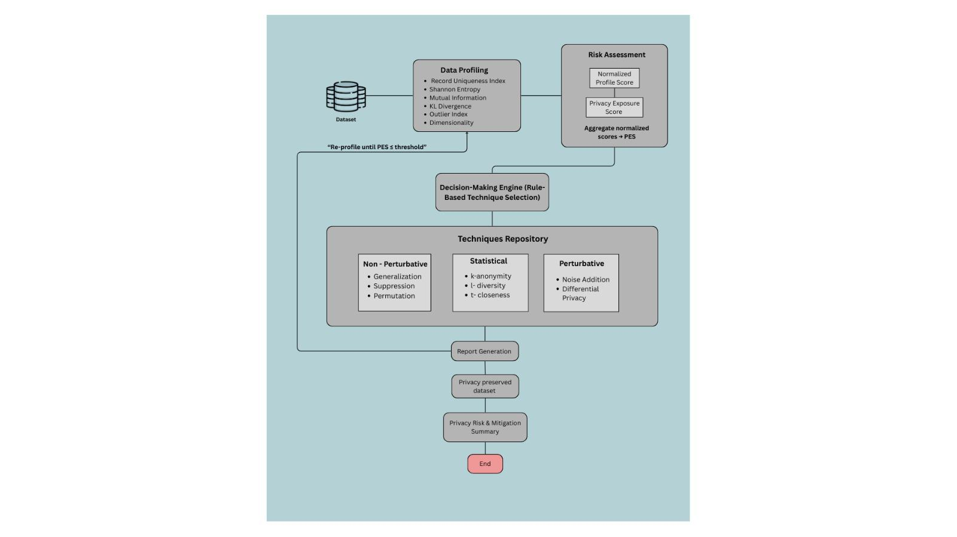
Fig. 1. Internal privacy workflow of the proposed framework. The dataset undergoes profiling, risk assessment, Privacy Exposure Score (PES) computation, rule-based technique selection, and iterative closed-loop transformations until the required privacy threshold is achieved.

4.1 Data Profiling and Privacy Risk Assessment
Figure 1 provides a detailed view of the internal privacy assessment pipeline. When a dataset enters the framework, the Data Profiling Module computes six foundational metrics. These privacy profiling metrics are used to quantify the characteristics of the dataset mathematically. These metrics influence privacy risk as it is related to uniqueness of the records, attribute diversity, inter attribute dependency and distributional variations. The numerical results helps in interpreting the dataset's privacy landscape and helps in making subsequent risk assessment

A) RECORD UNIQUENESS INDEX
Record​‍​‌‍​‍‌​‍​‌‍​‍‌ Uniqueness Index (RUI) is a metric that quantifies the percentage of records in a dataset that feature unique combinations of quasi-identifier values.
The RUI is essentially a measure of the probability of re-identification - the higher the RUI, the higher the risk of exposure, because a larger number of records can be separated from the ​‍​‌‍​‍‌​‍​‌‍​‍‌rest.
- First, the quasi-identifier attributes are listed by the system using data type and name-based heuristics, where relevant numerical and categorical columns are selected while ignoring other fields.
- Next, duplicate value combinations of quasi-identifiers are checked across these quasi-identifier columns.
- Then, the ratio is calculated using the formula:
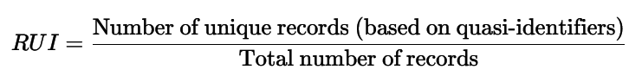
(Adapted from El Emam, 2009 – Re-identification Risk Metric)
- When RUI ≈ 1, there are many identical records, indicating a higher re-identification risk.
- When RUI ≈ 0, there are many shared combinations, indicating a lower re-identification risk.
B) SHANNON’S ENTROPY
Shannon's entropy measures how diverse or unpredictable the numerical values in a dataset are. It indicates the total amount of information present in the data — if most records have similar or repeating values, the entropy is low; if the values are more varied, the entropy is high.
- Firstly, the system calculates the entropy for each numeric column in the dataset.
- The frequency of each unique value is then determined, and the formula below is applied to measure the uncertainty and overall information diversity in the data.
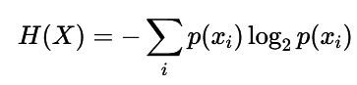
- where 𝑝(𝑥𝑖) represents the probability (or normalized frequency) of each unique value 𝑥𝑖 in the dataset.

- (Adapted from Shannon, 1948 – A Mathematical Theory of Communication)
- When H is low, data values are similar or repetitive, then high re-identification risk.
- When H is high, data values are more varied and less predictable, then low re-identification risk.
C) MUTUAL INFORMATION
Mutual​‍​‌‍​‍‌​‍​‌‍​‍‌ Information (MI) quantifies the extent to which one feature can assist in the prediction of another. It is a measure of the degree of dependency or shared information between the different columns of a ​‍​‌‍​‍‌​‍​‌‍​‍‌dataset.
- First, how the distribution of one attribute changes when grouped by another is checked
- If the pattern of one column's distribution depends on another, then it means they are highly related
- For every numerical-categorical pair it is calculated which can represent the overall dependency level of the dataset.
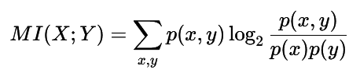
where p(x, y) is the joint probability of values x and y occurring together, p(x) and p(y) are their individual probabilities.
- (Adapted from Cover & Thomas, 1991 – Elements of Information Theory)
- When MI is high, attributes are highly related → higher privacy risk (sensitive data can be inferred).
- When MI is low, attributes are mostly independent → lower privacy risk (less chance of inference).
D) KL DIVERGENCE
Kullback–Leibler Divergence (D kl) measures how different two distributions are from each other. It indicates how much one attribute’s value distribution diverges from another’s.
- The difference between the normalised frequency distributions of every pair of numeric attributes are computed.
- Using it , the average kl divergence score for each pair is calculated to measure how the distributions differ.
- Finally, the average of all these divergence values to find how the overall distribution is unevenly distributed across the dataset.
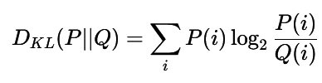
where P(i) and Q(i) represent the normalized probability distributions of two attributes being compared.
- (Adapted from Li et al., 2007 – T-Closeness Principle)
- When Dₖₗ is high, the distributions are very different → higher privacy risk (possible t-closeness violation).
- When Dₖₗ is low, the distributions are similar → lower privacy risk (better balance between attribute groups).
E) OUTLIER INDEX
​‍​‌‍​‍Outlier Index (OI) is a metric that indicates the presence and the strength of outliers in a dataset. Outliers being data points that are extremely far from the typical range of values, might expose unique or identifying information about individuals, thus increasing privacy risk.
More outliers are indicated by a higher OI number, which implies a higher possibility that the individual can be ​‍​‌‍​‍‌​‍​‌‍​‍‌identified.
- It starts with looking at the numeric columns in the dataset.
- IQR - Interquartile range is calculated for each column.
IQR = Q3 - Q1
where Q1 represent the first quartile which corresponds to 25th percentile - so 25% of the data lies below that value,
Q3 representS the third quartile which corresponds to 75th percentile - so 75% of the data lies below that value
- Q1 and Q3 together, they define the middle 50% of the data values — this is where most “normal” observations usually lie.
- So the datasets which fall below Q1 - 1.5 IQR or above Q3 + 1.5 IQR are detected as outliers
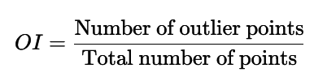
- (Adapted from Tukey, 1977 – Exploratory Data Analysis)
- When OI is high, many values fall outside the normal range → higher privacy risk (possible record uniqueness).
- When OI is low, most values are within a stable range → lower privacy risk (data is less distinguishable).
F) DIMENSIONALITY
Dimensionality​‍​‌‍​‍‌​‍​‌‍​‍‌ (DIM) is a measure of the number of effectively independent features that can be found in a data set. It indicates the amount of unique information that each column provides to put it simply, how many attributes are not significantly correlated with the others.
When a lot of columns are strongly correlated (for instance, one can be predicted from another), the dataset is said to have a lower effective ​‍​‌‍​‍‌​‍​‌‍​‍‌dimensionality.
- Firstly, the numeric columns are considered.
- The correlation between every pair of columns is calculated. This says how strongly they are related.
- If the correlation between 2 attributes have a value > 0.9, then they are considered redundant (almost containing the same information).
- The redundant attributes are subtracted from the total count to estimate the dimensionality.
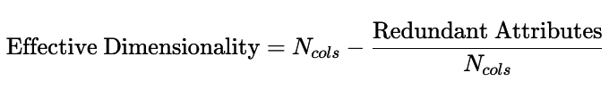
- (Adapted from Jolliffe, 2002 – Principal Component Analysis)
- When DIM is high, the dataset has many independent attributes → higher data complexity but potentially lower redundancy.
- When DIM is low, many attributes are similar or correlated → lower effective information and possibly higher re-identification risk (less variability across columns).
These​‍​‌‍​‍‌​‍​‌‍​‍‌ metrics combine to form the Normalized Profile Score that is further combined into the Privacy Exposure Score (PES). A high PES denotes a high privacy risk condition that demands a more powerful or layered intervention. The measurement makes it possible for the system to dynamically select the appropriate transformations instead of simply applying uniform anonymisation ​‍​‌‍​‍‌​‍​‌‍​‍‌methods.
A composite measure known as - Privacy Exposure Score (PES) represents the overall privacy risk of the dataset. PES is obtained as a combination of various measures of profiling with a given weight depending on the sensitivity of the measure to disclosure risk.
In which U is Record Uniqueness Index, E is the Shannon Entropy, M is Mutual Information, KL Divergence, O is the Outlier Index, D is Dimensionality and 𝛼 0 is the corresponding metric weights.
- Profiling metrics are extracted
- The metrics are normalized to bring them to a comparable scale (0–1).
- For each metric, weights are assigned based on its contribution to privacy risk.
- The weighted sum is calculated to obtain the final PES value.
- Categorize the dataset based on the PES score.
- Low Risk → PES < 0.33
- Medium Risk → 0.33 ≤ PES < 0.66
- High Risk → PES ≥ 0.66

4.2 Decision-Making Engine and Technique Selection
The PES and metric thresholds are given to the Decision-Making Engine (DME), which executes rule-based analysis to determine the most appropriate privacy-preserving transformations. The techniques repository is divided into:
- Non-perturbative methods: Generalisation, suppression, permutation
- Statistical anonymity methods: k-anonymity, l-diversity, t-closeness
- Perturbative methods: Noise addition, differential privacy
The Decision-Making Engine (DME) is the core element of the framework. It uses a rule-based conditional mapping to check the profiling metrics and the Privacy Exposure Score (PES) and thereby decide the best privacy-preserving techniques.
In order to preserve data utility, techniques are applied in an ordered manner from least to most invasive. The DME functions in a closed-loop manner—after every transformation, the dataset undergoes re-profiling and the PES is recalculated. The iteration goes on until the privacy risk drops below the set ​‍​‌‍​‍‌​‍​‌‍​‍‌threshold.
- Identify the nature of the privacy risk (e.g., identity disclosure, inference, outlier exposure).
- Map each detected risk to suitable privacy-preserving techniques.
- Prioritize and order the techniques to maximize data utility.
- Apply each transformation iteratively while monitoring PES to check if risk falls below a target threshold (usually 0.33).
Here, a structured conditional logic derived from empirical privacy theory and experimental validation is followed.
A) IDENTITY DISCLOSURE RISK (Record Uniqueness Ratio — RUI)
High RUI indicates that many records are unique or nearly unique, increasing re-identification risk.
- If RUI > 0.8 → High Risk
→ Apply k-Anonymity (k ≥ 10) to ensure identical groupings.
→ Apply Local Suppression to mask residual rare combinations.
- If 0.5 < RUI ≤ 0.8 → Moderate Risk
→ Apply l-Diversity (l=2) to maintain diversity among sensitive values.
- If RUI < 0.5 and Entropy is Low → Predictable Pattern Risk
→ Apply Generalisation, converting specific values (e.g., exact ages) into broader ranges (e.g., 30–39).
B) ATTRIBUTE INFERENCE RISK (Mutual Information — MI)
High MI indicates that sensitive attributes can be predicted from quasi-identifiers.
- If MI > 0.7 → Apply Differential Privacy (ε ≈ 0.3) + Noise Addition to decouple dependency.
- If 0.4 < MI ≤ 0.7 → Apply l-Diversity (l ≥ 3) for intra-group variability.
- If 0.2 < MI ≤ 0.4 → Apply Permutation to reorder records and break attribute linkages.
C) DISTRIBUTIONAL DISCLOSURE RISK (KL Divergence — KLD)
High divergence implies that the distribution of sensitive attributes differs significantly across equivalence classes.
- If KLD > 1.0 → Apply t-Closeness (t = 0.2) to restore distributional balance.
- If 0.5 < KLD ≤ 1.0 → Apply t-Closeness Adjustment (t = 0.1) for mild correction.

D) NUMERIC ATTRIBUTE DISCLOSURE (Entropy & Numeric Detection)
When the data set has numerical values or data of high-entropy:
- Apply Differential Privacy, adjusting ε inversely to PES:
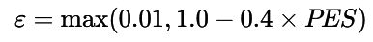
- Add Gaussian/ Laplacian Noise in relation to entropy:
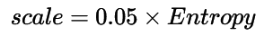
This makes sure that the numerical inference at an individual level is suppressed.

E) GLOBAL EXPOSURE RISK (Privacy Exposure Score — PES)
The PES offers a single privacy severity score (0 1).
- In case of PES 0.75 and above, use Strong Differentiated Privacy (ε 0.2 and less) and Suppression of high-risk datasets.
- When PES-0.5 < 0.75, use Moderate Differentiating Privacy ( ε 0.4).
- In the event of PES less than 0.5, use Light Noise Addition as a slight security measure.
In case none of the metrics meets any of the conditions, the fallback of Noise Addition (scale=0.02), is used to be conservative.

4.3 Closed-Loop Adaptation
After​‍​‌‍​‍‌​‍​‌‍​‍‌ the chosen methods have been implemented, the data undergoes further profiling and PES calculation. In case the PES is still higher than the allowed threshold, the DME will request a further refinement iteration. This closed-loop control, which is shown in Figure 1, operates until equilibrium is reached (i.e., PES ≤ target threshold). This loop of adaptation guarantees that the privacy safeguarding is sensitive to the risk features of each dataset.
The final anonymised data together with the Privacy Risk and Mitigation Report generated by the privacy framework are the output which is subsequently fed as input to federated ​‍​‌‍​‍‌​‍​‌‍​‍‌training.
Adaptive Closed-Loop Evaluation
The DME utilizes a closed-loop control in order to achieve solid and quantifiable privacy enhancement:
- First assessment: Calculate the profiling indicators and compute the base PES.
- Decision Phase : Select techniques based on metric conditions.
- Transformation Phase : Apply one or more chosen techniques in order.
- Re-Profiling Phase : Recalculate the metrics and recompute the PES after each iteration.
- Convergence Check :
- If PES ≤ target (0.33) → Stop (privacy risk mitigated).
- If PES > target → Re-enter the decision loop with updated metrics.
This​‍​‌‍​‍‌​‍​‌‍​‍‌ adaptive re-assessment makes certain that only the necessary level of anonymization is retained, thus no over-suppression is allowed while at the same time ensuring that privacy risk is mitigated.
Therefore, the​‍​‌‍​‍‌​‍​‌‍​‍‌ system takes an adaptive, metric-driven stance which means that it not only selects the appropriate privacy methods but also checks their effectiveness simultaneously.
By constantly supplying feedback, the system makes sure that the reduction of privacy risk is measurable and that the data utility is preserved at the highest possible level- thus, the DME is the main component that effectuates the change of the framework from a static anonymization system to a self-validating, closed-loop privacy assurance ​‍​‌‍​‍‌​‍​‌‍​‍‌​‍​‌‍​‍‌​‍​‌‍​‍‌model.

4.4 Contextual Architecture in Federated Analytics
The integration of the privacy framework into a federated learning environment is illustrated in Figure 2. Each participating institution hosts:
- Local Data (raw, never shared)
- Privacy Framework (profiling → PES → closed-loop privacy preservation)
- Local FL Client (training, evaluation, secure model update)
After the data is privacy-preserved, it is handed over to the local FL client for training a part of a shared model. Organizations exchange only model updates, not raw data. Central Federated Server performs aggregation of these updates in a secure manner to generate a global model, which is then shared with all the institutions again. This setup allows multiple institutions to collaborate without exposing sensitive records.
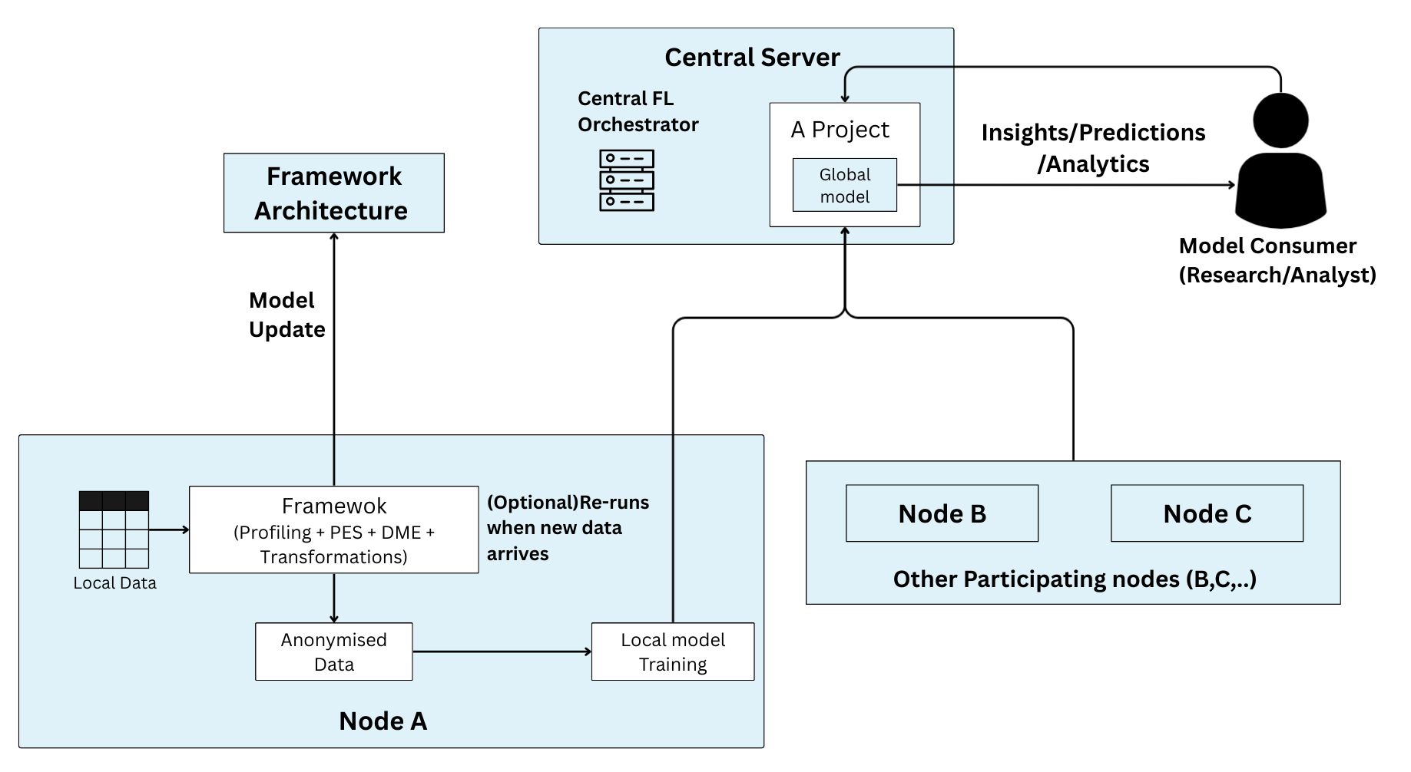

Fig. 2. Contextual architecture showing the integration of the privacy framework within a federated learning environment. Each node locally anonymises its dataset before training, while the central federation server aggregates secure model updates to produce a global model.

4.5 Federated Lifecycle Flow
Figure 3 illustrates the complete lifecycle starting from data collection up to finalized federated model convergence. The flow is as follows: First, the Data Owner is the one who starts the privacy assessment. Next, the Local Privacy Agent executes the full profiling– PES– DME– closed-loop pipeline operation and returns a privacy-preserved dataset. Following this, the Local FL Client performs training on this dataset, evaluates performance, and delivers secure model updates to the central server. After secure aggregation (SecAgg) and global model update, the new configuration and model parameters are sent back to all nodes to continue subsequent rounds.
The lifecycle continues until either the federated model converges or the performance requirements are met.In case there are new records at the institution, the framework will start the privacy pipeline again to guarantee continuous data ​‍​‌‍​‍‌​‍​‌‍​‍‌protection.

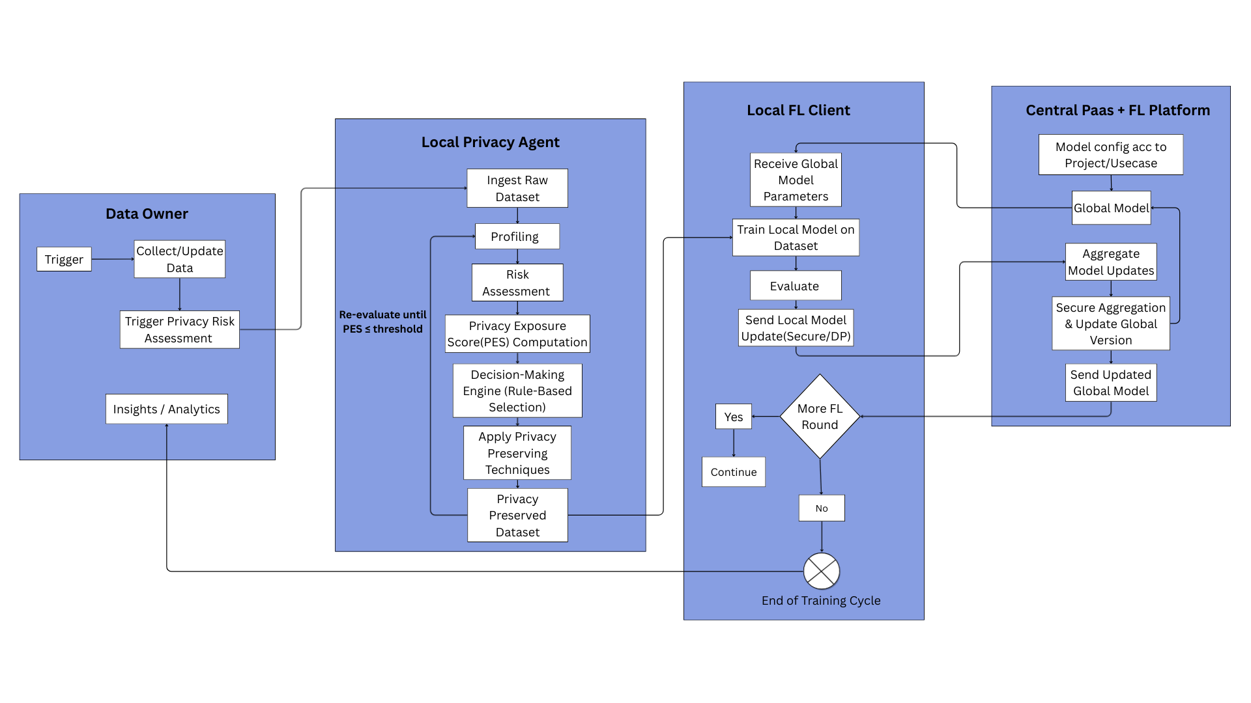

Fig. 3. End-to-end lifecycle flow from data collection to privacy preservation, local federated training, and secure aggregation at the central platform. The loop continues until model convergence, with optional re-execution of the privacy pipeline when new data arrives.

EXPERIMENTS
In this part, we evaluate the framework across 3 different datasets as follows :
DS1: Healthcare_visit.csv
DS2: Financial_data.csv
DS3: E_commerce.csv
Such​‍​‌‍​‍‌​‍​‌‍​‍‌ commentaries, being the outcomes of the framework processing, categorization, and development of insights of the datasets, indicate that the highlighted system is flexible, accurate, and efficient in handling diverse data types and in working with different ​‍​‌‍​‍‌​‍​‌‍​‍‌structures.

Experimental Setup
Tasks : The​‍​‌‍​‍‌​‍​‌‍​‍‌ main work of this research is the evaluation and alleviation of privacy risks in structured datasets, that is, both in a standalone and federated environments. To put it differently, it is necessary to carry out the entire pipeline of the presented framework: dataset profiling, calculation of the Privacy Exposure Score (PES), picking privacy-preserving techniques by the Decision-Making Engine (DME), and iterative mitigation to the level of privacy that is considered sufficient.A secondary task is to determine the framework's behaviour in a federated setting, where datasets before being included in a shared analytics environment are screened to ensure that they meet privacy thresholds. Moreover, the system is designed to do the so-called continuous monitoring of a dynamic dataset that is being incrementally updated over time and thus allows the study of the effect data evolution has on risk levels and the need for adaptive privacy protection. These works, in fact, constitute a comprehensive program for proving the closed-loop architecture effectiveness, scalability, and robustness in different deployment ​‍​‌‍​‍‌​‍​‌‍​‍‌scenarios.
Datasets : The experimental evaluation utilizes three structured datasets – DS1: Healthcare_visits.csv, DS2: Financial_data.csv, and DS3: E_commerce.csv – The​‍​‌‍​‍‌​‍​‌‍​‍‌ datasets were chosen to reflect different domains and different degrees of privacy sensitivity. DS1 is composed of anonymized healthcare visit records that include demographic details, diagnosis codes, and service information. Hence, it is a highly sensitive dataset and can be used to evaluate the system's capacity to identify and alleviate medical privacy risks. DS2 is made up of financial transaction data, spending patterns, and account-level summaries and is a domain in which quasi-identifiers can substantially contribute to re-identification and linkage risks. DS3 is a set of e-commerce browsing histories, purchase logs, and product interaction attributes that, although less sensitive, can still cause behavioural and linkability ​‍​‌‍​‍‌​‍​‌‍​‍‌risks.
Metrics : The​‍​‌‍​‍‌​‍​‌‍​‍‌ framework assesses privacy risks by introducing quantitative metrics that are aligned with various disclosure risk types, thus allowing exact and targeted risk reduction. Identity Disclosure Risk is gauged by the Record Uniqueness Ratio (RUI), a measure that singles out how many records are unique or almost unique. Data with RUI > 0.8 are considered to be of high risk and thus k-Anonymity (k ≥ 10) combined with local suppression is used for mitigation, whereas datasets at a medium risk level (0.5 < RUI ≤ 0.8) make use of l-Diversity (l=2). Where RUI is low but entropy is also low—which signals that the patterns are predictable—generalisation is utilized to change the specific values into wider ​‍​‌‍​‍‌​‍​‌‍​‍‌ranges.
- Attribute ‍ ‌​‍​‌‍​‍‌​‍​Inference Risk is measured with Mutual Information (MI), which indicates the degree to which quasi-identifiers can be used to predict sensitive attributes. Situations with a very high risk (MI > 0.7) are relieved by Differential Privacy (ε ≈ 0.3) and noise addition to disrupt attribute dependencies. Intermediate degrees (0.4 < MI ≤ 0.7) cause the implementation of l-Diversity (l ≥ 3), and the lower, though still considerable, risks (0.2 < MI ≤ 0.4) are dealt with by permutation so as to sever direct correlation links.
- Distributional​‍​‌‍​‍‌​‍​‌‍​‍‌ Disclosure Risk is measured by KL Divergence (KLD), which points out differences between the distributions of sensitive attributes across the equivalence classes. Large divergence (KLD > 1.0) enforces the use of t-Closeness (t = 0.2), whereas moderate divergence (0.5 < KLD ≤ 1.0) is remedied by means of a lighter t-Closeness adjustment (t = 0.1). ​‍​‌‍​‍‌​‍​‌‍​‍‌
- When​‍​‌‍​‍‌​‍​‌‍​‍‌ handling datasets with numerical or high-entropy attributes, Entropy is used as a measure for Numeric Attribute Disclosure Risk. To ensure the privacy of high-entropy numeric records, Differential Privacy is implemented with ε adjusted inversely to the total Privacy Exposure Score, and either Gaussian or Laplacian noise is added to hide individual-level ​‍​‌‍​‍‌​‍​‌‍​‍‌inference.
- Global​‍​‌‍​‍‌​‍​‌‍​‍‌ Exposure Risk along with a Privacy Exposure Score (PES) that varies from 0 to 1 is the main tool which presents a holistic view. Data sets with PES ≥ 0.75 are given a strong differential privacy (ε ≤ 0.2) and can also have extremely high-risk attributes suppressed. In case of moderate PES values (0.5 < PES < 0.75), differential privacy is used at a moderate level (ε ≈ 0.4), while in the case of low-risk datasets (PES < 0.5), only a small amount of noise is added. In case no metrics are there to trigger an intervention, a conservative fallback noise addition (scale = 0.02) is carried ​‍​‌‍​‍‌​‍​‌‍​‍‌out.
The​‍​‌‍​‍‌​‍​‌‍​‍‌ Decision-Making Engine (DME) chooses the mitigation methods in a hierarchical manner as follows: Generalisation, k-Anonymity, l-Diversity, t-Closeness, Noise Addition, Differential Privacy, Permutation, and finally Suppression while trying to keep the balance between the strength of privacy and the data utility. The framework is essentially a closed-loop one: it calculates the initial metrics and PES, implements the selected techniques, re-profiles the dataset, recalculates the metrics, and verifies if the PES has reached the target threshold (PES ≤ 0.33). If not, the system is going through the decision loop again, iteratively, until it ​‍​‌‍​‍‌​‍​‌‍​‍‌converges.
Each metric contributes to a specific risk category within this closed-loop adaptive system:
- RUI​‍​‌‍​‍‌​‍​‌‍​‍‌ reduces the risk of identity disclosure.
- Entropy decreases the possibility of prediction by means of generalisation.
- MI limits attribute inference by using Differential Privacy, noise, and permutation.
- KLD lessens the risk of distributional disclosure by implementing t-Closeness.
- PES controls the overall privacy level as well as the final convergence.
This multi-metric evaluation ensures comprehensive, quantifiable, and adaptive privacy protection for both static and dynamic datasets.

Experimental Results
Use case 1 : Healthcare Visits data had both a good balance of numerical and categorical variables. The numbers such as age, systolic and diastolic blood pressure, and total cholesterol levels co-occurred with the non-numerical variables such as gender, diagnosis codes, and medications being prescribed. This dataset has proved as a great tool in the test of the framework to support the various types of data in correlation analysis, patient profiling through clustering, and identification of abnormal medical values. Its formatting was a true drawback in its application to real world data whereby numeric and categorical data are of equal significance.
patient_id | age | gender | diagnosis_code | systolic_bp | diastolic_bp | cholesterol_mg_dl | visit_date | prescribed_med
P300001 | 62 | M | J00 | 150 | 67 | 209 | 2022-07-31 | Atorvastatin
P300002 | 59 | M | E11 | 134 | 98 | 267 | 2023-10-08 | Metformin
P300003 | 65 | M | R51 | 103 | 80 | 262 | 2025-06-01 | Ibuprofen
P300004 | 9 | F | K21 | 149 | 85 | 271 | 2022-04-30 | Atorvastatin

The framework is applied on this dataset to mask the direct and quasi identifiers using suppression and generalization techniques and applies differential privacy for the numerical attributes in the dataset.

patient_id | age | gender | diagnosis_code | systolic_bp | diastolic_bp | cholesterol_mg_dl | visit_date | prescribed_med
 | 60-70 | M | J00 | 124.937 | 83.066 | 256.836 |  | Atorvastatin
 | 50-60 | M | E11 | 117.514 | 85.787 | 405.004 |  | Metformin
 | 60-70 | M | R51 | 143.804 | 77.650 | 291.000 |  | Ibuprofen
 | 0-10 | F | K21 | 137.406 | 77.755 | 278.316 |  | Atorvastatin

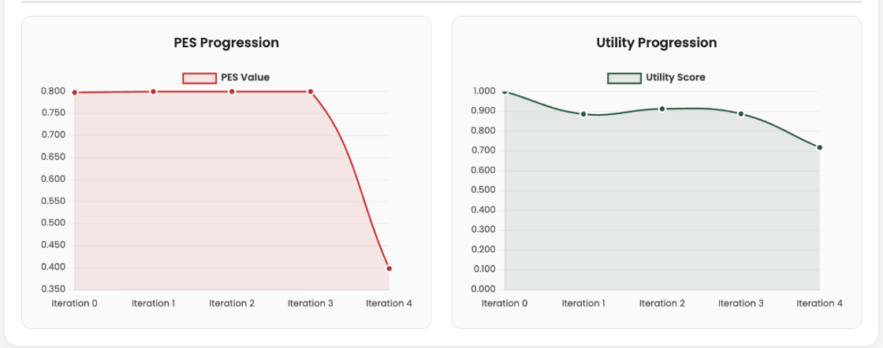

Use case 2 : The Finance Transactions dataset was predominantly numeric with statistics like the volume of transactions, account balance, and transaction date and only a small percentage of attributes were nominal like transaction type, merchant, and category. Therefore, it constituted a numerically overwhelming data. It was also a valuable tool in subjecting the system to its test in the context of continuous value processing, arithmetic computation and numerical anomaly detection such as an abnormally high expenditure or an incorrect balance update.

transaction_id | account_id | date | amount | transaction_type | merchant | category | balance_after
T200000 | A50059 | 2025-03-16 | 92.86 | debit | Amazon | food | 9566.32 | …
T200001 | A50012 | 2025-05-16 | 731.13 | credit | Starbucks | food | 10065.49 | …
T200002 | A50010 | 2025-06-20 | 452.91 | credit | Apple | salary | 9343.6 | …
T200003 | A50185 | 2025-06-12 | 546.16 | credit | Walmart | rent | 1629.56 | …

Being a categorical dataset, the framework is applied on this dataset to mask the direct and quasi identifiers using suppression and generalization techniques and applies differential privacy for the only few numerical attributes in the dataset using adaptive noise.

transaction_id | account_id | date | amount | transaction_type | merchant | category | balance_after
 |  |  | 1639.0699794589200 | debit | Amazon | food | 12650.990729640800
 |  |  | 896.8842646713280 | credit | Starbucks | food | 1646.1178190153200
 |  |  | 2101.3503683960600 | credit | Apple | salary | 2732.499017672070
 |  |  | 1696.1977943714900 | credit | Walmart | rent | 7434.9705714461900

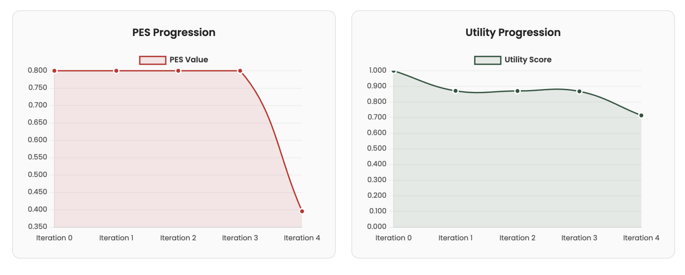

Use case 3 : The​‍​‌‍​‍‌​‍​‌‍​‍‌ E-commerce Orders dataset was primarily categorical. It had a major part of its attributes as descriptive ones like product category, country, and order status, while the numerical columns like price and quantity were in the minority. As a result, it was a good tool for evaluating the framework's handling of categorical data, e.g. grouping, aggregation, and frequency-based trend analysis. Besides, it helped in checking the framework's capability in generating concise business insights such as category-wise performance and regional distribution of sales from the dominant categorical ​‍​‌‍​‍‌​‍​‌‍​‍‌features.

order_id | user_id | product_id | category | price | quantity | order_date | shipping_country | order_status
O400001 | U10429 | PR7245 | Groceries | 1421.82 | 2 | 2022-06-17 | USA | shipped
O400002 | U10318 | PR7222 | Beauty | 14207.95 | 4 | 2022-06-09 | USA | returned
O400003 | U10589 | PR7481 | Home | 11770.46 | 5 | 2022-01-20 | Australia | cancelled
O400004 | U10283 | PR7104 | Electronics | 19822.15 | 4 | 2024-07-13 | India | cancelled

Being a mixed dataset of categorical and numerical attributes, the framework is applied on this dataset to mask the direct and quasi identifiers using suppression and generalization techniques and applies differential privacy for the only few numerical attributes in the dataset using adaptive noise.
order_id | user_id | product_id | category | price | quantity | order_date | shipping_country | order_status
 |  |  | Groceries | 16841.949 | 1.6028 |  | USA | shipped
 |  |  | Beauty | 9314.1473 | 0.9419 |  | USA | returned
 |  |  | Home | 14809.126 | -0.4842 |  | Australia | cancelled
 |  |  | Electronics | 24918.525 | 3.999 |  | India | cancelled

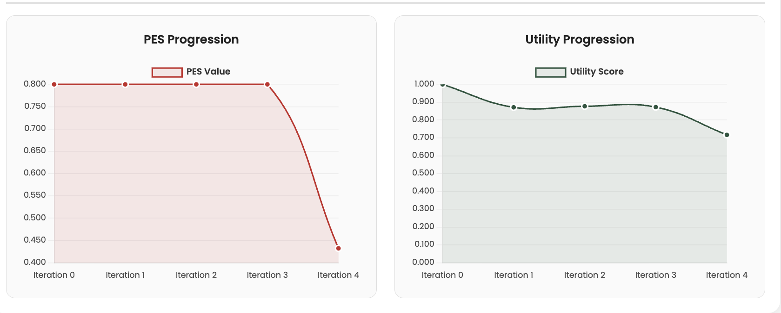

DISCUSSIONS
The​‍​‌‍​‍‌​‍​‌‍​‍‌ results reveal that the framework has been able to significantly reduce privacy risks while maintaining a high level of data utility through the use of appropriate privacy enforcement mechanisms across all the datasets tested. In sectors like Finance, Healthcare, and E-commerce, the sensitive attributes were protected without a significant drop in analytical quality or model performance. The framework has demonstrated its capability in balancing privacy and usability : thus, facilitating the anonymization or masking of financial transactions, patient records, and user behaviors that are the confidential details, while allowing the necessary patterns and statistical relationships to be retained. This finding is a signal that the implemented privacy safeguards have effectively lowered the risk of disclosure and at the same time, have guaranteed the overall integrity, accuracy, and usefulness of the processed data ‌ ‍ ​‍​‌‍​‍‌​‍​‌‍.

CONCLUSION
This​‍​‌‍​‍‌​‍​‌‍​‍‌ paper introduced a Framework that aims to evaluate and lessen privacy risks in structured datasets that are to be used analytically or in a federated manner. The framework combines dataset profiling, privacy risk measurement using the Privacy Exposure Score (PES), and the deployment of adaptive mitigation methods within a modular and closed-loop system. In this way, it offers quantifiable privacy guarantee besides the transformed privacy-preserved dataset and the report detailing the risk metrics and the post-mitigation trends.
The findings demonstrated that privacy risks have been substantially reduced while the data utility was kept at a high level, thus the superiority of adaptive enforcement over static anonymization was convincingly proven.
The tool serves as a very good example of the effective identification and subsequent reduction of privacy risks in a systematic and measurable way thus, before data sharing, safer data handling and the resulting trust in data-driven processes are ensured.
Subsequent work can extend this framework simulation within a federated learning setting to assess the effects in such real-world collaborative data scenarios. The research can focus on privacy attacks' behavior when raw datasets are used versus transformed (privacy-preserved) datasets. These experiments will let them measure the increase in privacy protection that the framework provides, thus serving as another validation of its effectiveness in distributed and privacy-sensitive machine learning ‌ ‍ ​‍​‌‍​‍‌​‍​‌‍​‍‌applications.

REFERENCES
[1] El Emam, K. (2009). Risk-Based De-Identification of Health Data: Re-Identification Risk Metric. Journal of Biomedical Informatics, 42(1), 28–39.
[2] Shannon, C. E. (1948). A Mathematical Theory of Communication. Bell System Technical Journal, 27, 379–423 & 623–656
[3] Cover, T. M., & Thomas, J. A. (2006). Elements of Information Theory (2nd ed.). Wiley-Interscience
[4] Li, N., Li, T., & Venkatasubramanian, S. (2007). t-Closeness: Privacy Beyond k-Anonymity and l-Diversity. Proc. 23rd International Conference on Data Engineering (ICDE), 106–115
[5] Tukey, J. W. (1977). Exploratory Data Analysis. Addison-Wesley..
[6] Jolliffe, I. T. (2002). Principal Component Analysis (2nd ed.). Springer Series in Statistics
[7] S. Gambs, M.-O. Killijian, and M. N. Navarro, “PPaaS: Privacy Preservation as a Service,” Computer Communications, vol. 176, pp. 1–10, 2021.
[8] X. Liu, Y. Chen, and H. Jin, “Anonymizing Data for Privacy-Preserving Federated Learning,” arXiv preprint arXiv:2002.09096, 2020.
[9] Axtria Inc., “A Mathematical Framework for Assessing Privacy Risk in BFSI,” Axtria Blog, 2021.

